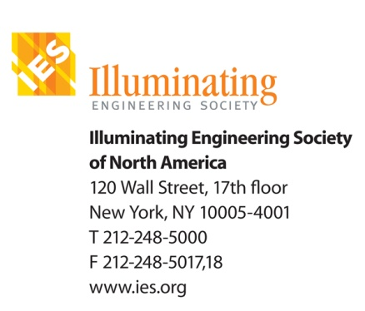

Jeff Milham
The Nuckolls Fund for Lighting Education
12 Mill Pond Road
Putnam Valley, NY 10579

Fred Oberkircher
231 Stone Bridge Trail East
Dunlap, TN 37327

Dear Jeff & Fred:

In consideration of the financial support that the Nuckolls Fund for Lighting Education has provided the 2012 Light + Seniors Symposium, the Illuminating Engineering Society officially permits the Nuckolls Fund to post and distribute through their web site the proceedings of the 2012 Light + Seniors Symposium without remuneration to the IES.

Sincerely,
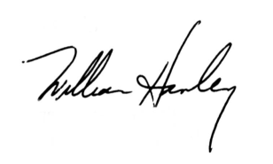
William Hanley, CAE
Executive Vice President

