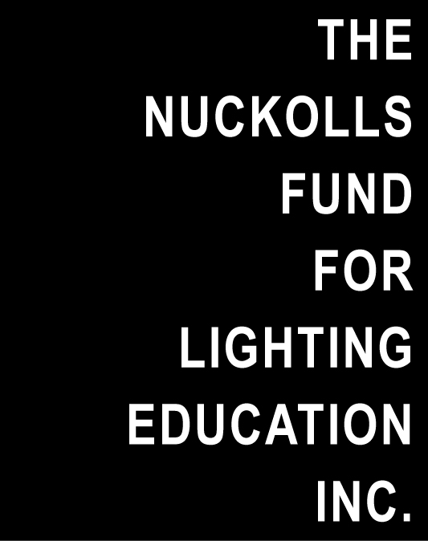
For Immediate Use
For further information, please contact:
Jeffrey A. Milham, jeffmilham@aol.com, or
Vilma Barr, Barr Publications & Editorial Services,
917-796-4318, vilmabarr@aol.com

Panichella Joins Nuckolls Fund Board

Jim Panichella is a new member of the Board of Directors of The Nuckolls Fund for Lighting Education. He is co-president of International Lights, Inc., a New York City-based sales agency representing major lighting manufacturers.
Panichella, who has a B.S in Architectural Engineering with a specialty in lighting from Pennsylvania State University, began his career with Zumtobel Lighting before moving to specification sales at International Lights. He is a member of the Illuminating Engineering Society.
The Nuckolls Fund for Lighting Education was founded in 1989 in honor of the late lighting designer and educator, James L. Nuckolls. To date, The Nuckolls Fund has given a total of $935,000 for the advancement of lighting education in North America.
Additional information about The Nuckolls Fund for Lighting Education can be found on www.nuckollsfund.org. Posted on the site in the Educational Resources section are: video excerpts from the Nuckolls Fund award program, “Architectural Lighting Design Workshops;” seven individual teaching modules, “Lighting Across the Design Curriculum,” funded by a $50,000 Nuckolls Fund Twentieth Anniversary Grant; and the teaching module, “Lighting Controls—Tools for Teaching,” developed by a Nuckolls Fund Edison Price Fellowship Grant.
Proposals are solicited annually by The Nuckolls Fund for innovative educational ideas to advance the understanding of light in architecture. For further information, contact Jeffrey A. Milham, president of The Nuckolls Fund for Lighting Education, at jeffmilham@aol.com.

# # #

CAPTION:

Jim Panichella of International Lights, Inc., New York, has been named to the Board of Directors of The Nuckolls Fund for Lighting Education.

Photo: Jesse Ross

