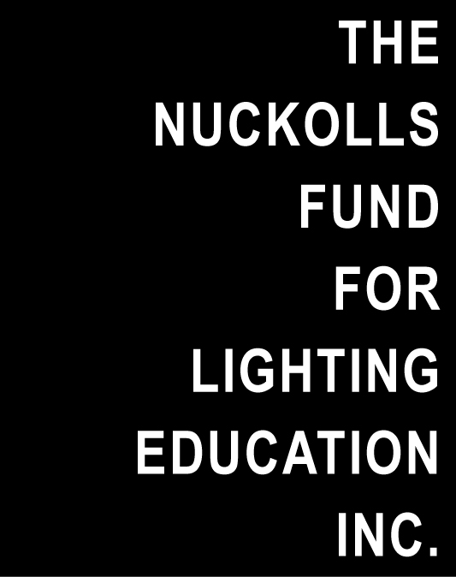
For Immediate Use
For further information, please contact:
Jeffrey A. Milham, jeffmilham@aol.com,
or Vilma Barr, Barr Publications & Editorial Services,
917-796-4318, vilmabarr@aol.com

NUCKOLLS FUND AWARDS $60,000 TO SIX 2015 WINNERS

The Nuckolls Fund for Lighting Education presented a total of $60,000 for lighting education grants and awards at its annual luncheon held at Lightfair International 2015 in New York City on May 5. Founded in 1989 in honor of the late lighting designer and educator, James L. Nuckolls, The Nuckolls Fund has to date contributed $935,000 for the advancement of lighting education in North America.
Proposals are solicited annually by The Nuckolls Fund for innovative educational ideas advancing the understanding of light in architecture. This year, Jeffrey A. Milham, president of The Nuckolls Fund, presented two $20,000 Nuckolls Fund grants and four $5,000 student awards.

$20,000 Nuckolls Fund Grants
- C&C Lighting, Pittsburgh, headed by Cindy Limauro, Professor of Lighting Design, School of Drama and Architecture, Carnegie Mellon University, and her husband, lighting designer Christopher Popowich, received the $20,000 grant as an extension of Limauro’s 2013 and 2014 Nuckolls Fund grants. C&C Lighting will continue the presentation of an Architectural Lighting Design Workshop series at schools of architecture to encourage the initiation of new courses or expansion of existing programs in lighting design. Eight universities have so far participated in the program. A teaching video to be used by university design educators will become available by Fall, 2015.

- Mississippi State University was awarded a $20,000 grant to develop and deliver a new course in lighting to be called, “Integrated Lighting Solutions”. Robin Carroll and William Reihm are creating the course as a new interdisciplinary effort across four academic units: interior design, architecture, building construction science, and industrial and system engineering. It will assist Mississippi State University in the development of a sufficient number of new lighting courses to establish a lighting certificate program at the university.

$5,000 Nuckolls Fund Awards
- The Jonas Bellovin Scholar Achievement Award recognizes a student who has demonstrated outstanding performance in an existing lighting program. This year’s $5,000 award was presented to Stephen Finney, an MFA student graduating with double majors in both lighting design and interior design at Parsons The New School for Design in New York City.

- The $5,000 Jules Horton International Student Achievement Award is given annually to an international student who has come to the United States to study and has shown to be outstanding in his or her lighting studies. The 2015 recipient is Arpan Guha now at the University of Nebraska at Lincoln. After obtaining a BS degree in Electrical Engineering and an MS degree in Lighting in India, he is in the first year of an Architectural Engineering PhD program at UN-Lincoln focused on lighting.

- Two $5,000 Designers Lighting Forum of New York Student Achievement Awards were presented for the first time at this year’s Nuckolls Fund award ceremony.
Charles Jarboe is enrolled in the MS in Lighting program at Rensselaer Polytechnic Institute’s Lighting Research Center where he has excelled academically both in research and in design. Mr. Jarboe intends to use some of his award to visit Sri Lanka to further develop and refine his lighting design for a UNESCO World Heritage Site.
Craig Casey is studying lighting at Pennsylvania State University where he is currently a PhD student in the Architectural Engineering program to be completed later this year. He assisted in the development of software in topics relating to daylighting and photo sensor control system modeling. His objective is to become a university-level lighting educator. Casey was named chair of the IES Conference Steering Committee to plan the 2015 IES Conference

Nuckolls Fund president Milham closed the event by announcing the completion of an electronic database of lighting educators for communication and encouraging the use of the free educational resources offered on The Nuckolls Fund website, www.nuckollsfund.org. Said Milham, “This is our outreach to all those who are eager for lighting design education, whether they are lighting students, lighting teachers, or lighting design practitioners. We have openly shared our database with the IALD Education Trust, the IES Education Committee and the IES Teachers of Lighting Workshop coordinators. It benefits all of those organizations,” Milham concluded.

NOTE TO EDITORS: PLEASE INCLUDE THE FOLLOWING IN YOUR CALENDARS:
Proposals for the 2016 Nuckolls Fund for Lighting Education grants are due on February 6, 2016. For further details, visit www.nuckollsfund.org to download the current grant RFP or to make a donation to the Fund.
# # #

